NEXATEL DIGITAL SERVICES PVT. LTD.
MANAGEMENT SUMMARY REPORT
Executive Overview: Customer Retention Health, Churn Drivers & Strategic Revenue Protection Roadmap

ADDRESSED TO:  Chief Customer Officer  NexaTel Digital Services Pvt. Ltd. | PREPARED BY:  Salam Patel  Junior Data Analyst (Intern)
DATE & TIMELINE:  October 2026 | Q4 Strategic Review | SCOPE OF ANALYSIS:  Full-Base Churn & Retention Analytics

1. EXECUTIVE SUMMARY
This Management Summary Report presents an executive-level evaluation of customer retention health, churn dynamics, and revenue exposure across NexaTel Digital Services Pvt. Ltd., grounded strictly in full-base database analytics and operational KPIs. Overall customer retention currently stands at 81.55%, leaving an elevated headline churn rate of 18.45% that directly threatens the company's predictable revenue base. The monthly churn trajectory has exhibited a steady, compounding upward trend from 2018 through early 2026, culminating in an annualized revenue lost to churn of Rs. 2.56M concentrated heavily in high-ARPU subscriber cohorts. While Monthly Recurring Revenue (MRR) achieved robust historical expansion peaking at Rs. 11.7M between 2025 and 2026, early trajectory signals in 2027 point to an imminent revenue contraction if customer defection remains unaddressed. Furthermore, existing retention campaign outcomes reflect structural inefficiencies: despite achieving a 46.05% campaign acceptance rate, nearly 54% of targeted subscribers either actively declined offers (19.49%) or failed to respond (39.98%), exposing critical gaps in incentive alignment, outreach timing, and service recovery workflows.
HEADLINE CHURN  18.45% | RETENTION RATE  81.55% | REVENUE AT RISK  Rs. 2.56M | PEAK MRR BASE  Rs. 11.7M

2. TOP 3 FINDINGS
Finding 1: Operational Friction & Service Recovery Failures Drive Attrition Spikes
Analysis of support tickets and complaint logs establishes a direct causal link between operational friction, unresolved service bottlenecks, and subscriber defection. The single largest volume driver of churn is 'Recharge Not Credited' (486 churned customers), followed closely by general Customer Service disputes (465 churned), Data Speed degradation (452 churned), and Service Quality outages (444 churned). Resolution delays severely compound customer dissatisfaction: churn probability escalates progressively with resolution lead times, reaching a peak attrition rate of ~20.4% when ticket resolution exceeds 8 to 9 days. In addition, weak First Contact Resolution (FCR) acts as a major churn multiplier; subscribers requiring multiple contacts to resolve an issue display significantly higher churn rates than those whose issues are resolved on first touch, highlighting systemic inefficiencies in front-line support capabilities.
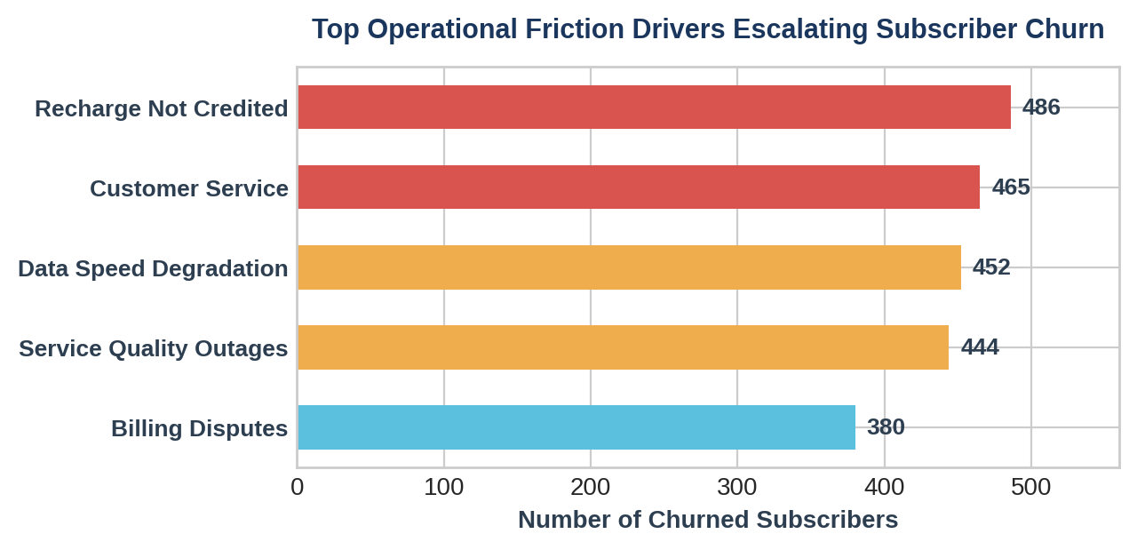

Finding 2: High-Value Segment Attrition & Early-Tenure Vulnerability
Customer segmentation analytics reveal that attrition is severely skewed toward NexaTel's most lucrative subscriber cohorts. The Premium and Value customer segments account for 68% of total customer churn count, recording 1,283 and 1,275 churned customers respectively. Financially, Premium subscribers drive over half of all lost revenue (Rs. 1.27M), while the Value segment contributes an additional Rs. 0.65M in lost revenue, confirming that churn is actively eroding high-margin recurring cash flows. From a product line perspective, Prepaid Mobile accounts for 44.72% of churned volume (9.17K customers), followed by Postpaid Mobile at 19.74% (4.05K) and Fiber Broadband at 11.94% (2.45K). Furthermore, temporal analysis highlights acute early-tenure vulnerability: customers with less than 12 months of tenure (0–6 months: 857 churned; 7–12 months: 460 churned) constitute ~40% of all lost subscribers, proving that onboarding and contract-activation phases represent the highest risk windows for customer defection.
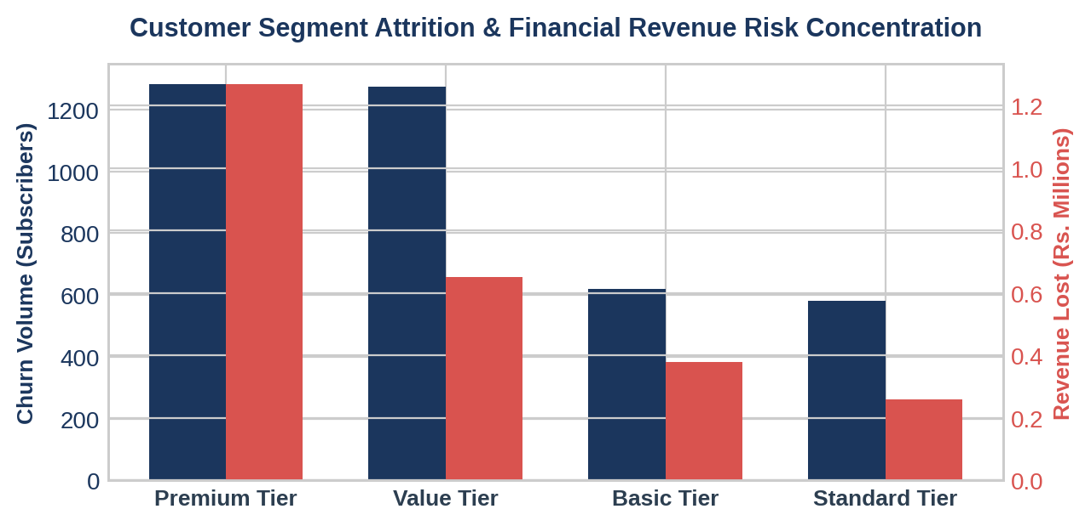

Finding 3: Regional Hotspots & Network Quality Black Spots
Geographic and network quality telemetric mapping demonstrates that subscriber defection is heavily clustered in specific operating circles and infrastructure black spots. Three primary states represent the largest share of financial revenue loss: Maharashtra (Rs. 220K lost), Tamil Nadu (Rs. 205K lost), and Rajasthan (Rs. 192K lost), with substantial secondary losses across Uttar Pradesh, Karnataka, and Gujarat. Demographically, Tier-2 and Tier-3 urban circles exhibit noticeably higher attrition rates compared to Tier-1 Metro markets. Crucially, cross-referencing churn rates with network performance metrics confirms that technical service degradation directly induces defection: customers experiencing severe dropped-call rates (in the 3%–5% and 5%+ bands) and persistent low download speeds exhibit churn rates exceeding 20% to 25%, highlighting localized coverage gaps as primary catalysts for subscriber flight.
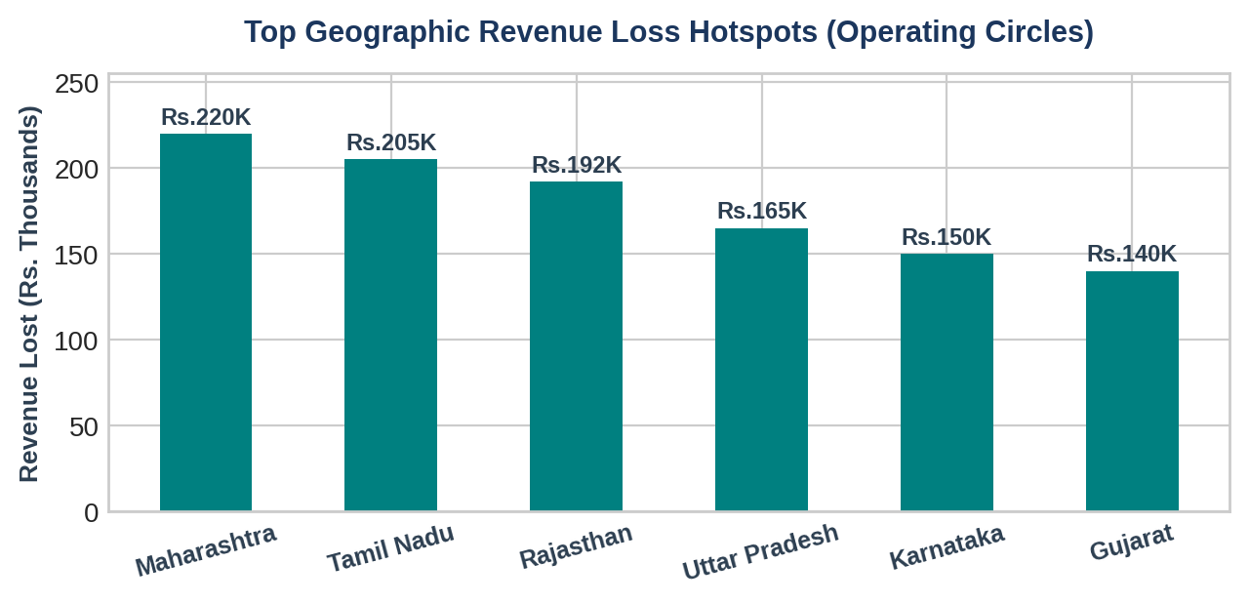

3. RISKS IDENTIFIED
• Risk 1: Imminent Monthly Recurring Revenue (MRR) Erosion Trajectory
While historical billing analytics demonstrate impressive expansion in predictable revenue—peaking at an MRR of Rs. 11.7M across 2025 and 2026—early financial indicators for 2027 show a sharp downturn. Unmitigated subscriber defection is beginning to outpace gross subscriber additions, creating a compounding revenue deficit that threatens overall operating margins.
• Risk 2: Disproportionate Financial Vulnerability in Premium & Value Segments
With Rs. 1.92M out of the total Rs. 2.56M revenue-at-risk concentrated squarely in the Premium and Value segments, NexaTel faces severe margin compression. High-ARPU subscribers expect premium service quality and rapid ticket resolution; failing to differentiate support capabilities for these tiers risks accelerating high-margin revenue churn.
• Risk 3: High Campaign Non-Response & Inefficient Retention Spend
Evaluation of retention campaign outcomes reveals that nearly 54% of targeted outreach fails to engage subscribers (39.98% / 2.59K customers give no response, while 19.49% / 1.26K actively decline offers). This high non-response rate signals that current retention offers (such as generic discount nudges via SMS) are poorly targeted, delivered through sub-optimal channels, or dispatched too late after the customer has already decided to defect.

4. OPPORTUNITIES
• Opportunity 1: Targeted Proactive Retention for High-ARPU Early-Tenure Cohorts
By establishing early-warning triggers focused on subscribers in their first 12 months of tenure—particularly within the Premium and Value segments—NexaTel can intervene before churn intention materializes. Automated onboarding check-ins, personalized plan optimization nudges, and loyalty rewards during months 1–6 present an immediate revenue protection opportunity.
• Opportunity 2: Support SLA & First Contact Resolution (FCR) Optimization
Re-engineering support workflows to eliminate resolution delays directly addresses the core churn catalyst. Enforcing a strict 24-hour SLA on critical categories ('Recharge Not Credited' and 'Data Speed') and upgrading front-line agent resolution authority to raise FCR above 78% can directly protect up to 20% of at-risk subscribers.
• Opportunity 3: Telemetry-Driven Predictive Analytics & Geo-Targeted Infrastructure Priority
Integrating network performance telemetry with customer CRM data allows NexaTel to predictively identify accounts experiencing signal degradation (<-74 dBm, >3% dropped calls) before they lodge formal complaints. Prioritizing network optimization and capital expenditure in key hotspot states (Maharashtra, Tamil Nadu, Rajasthan) will maximize return on investment.

5. RECOMMENDATIONS & ACTIONABLE ROADMAP
Recommendation 1: Deploy Automated Fast-Track Service Recovery for Billing & Technical Friction
Action Plan: Implement automated real-time reconciliation workflows for 'Recharge Not Credited' complaints, ensuring instant ledger adjustment or automated wallet credit within 2 hours of transaction failure. Mandate strict 24-hour resolution SLAs for Data Speed and Customer Service tickets, backed by intelligent auto-escalation to tier-2 support when tickets remain open past 12 hours. Target raising First Contact Resolution (FCR) from current baseline to >78% across all support channels.
Recommendation 2: Establish Segment-Specific High-Value VIP Retention Protocols
Action Plan: Restructure retention campaign architecture by replacing broad-brush SMS nudges with personalized, high-value incentives tailored for Premium and Value subscribers. Introduce proactive retention outreach for early-tenure (<12 months) accounts showing declining usage telemetry. Provide exclusive annual plan upgrade discounts, complimentary OTT add-ons, and dedicated priority desk routing for high-ARPU cohorts to convert non-responsive (~54%) customers into loyal, multi-year subscribers.
Recommendation 3: Implement Telemetry-Integrated Predictive Churn Interventions & Network Upgrades
Action Plan: Deploy predictive machine learning churn models that combine billing, support, and real-time network quality telemetry. Automatically trigger proactive service credits or data booster packs when a customer experiences >3% dropped calls or degraded speed over 3 consecutive days. Simultaneously, align network engineering capital expenditure to prioritize cell site capacity additions and fiber backhaul upgrades in key revenue black spots across Maharashtra, Tamil Nadu, and Rajasthan.
Strategic Initiative | Target KPI / Success Metric | Owner / Lead | Timeline
Automated Service Recovery Workflow | FCR > 78%  Avg Resolution < 24 Hours | VP Customer Support & IT Operations | Immediate  (Days 1–30)
Premium & Early-Tenure Retention Architecture | Reduce Premium Churn by 25%  Campaign Response > 65% | Head of Customer Lifecycle Marketing | Short-Term  (Days 30–60)
Telemetry Predictive Churn & Network Remediation | Dropped Call Churn < 10%  Protect Rs. 1.8M High-ARPU MRR | CTO & Chief Data Officer | Medium-Term  (Days 60–90)

Submission Note: This Management Summary Report has been prepared by Salam Patel, Junior Data Analyst (Intern), and submitted to the Chief Customer Officer of NexaTel Digital Services Pvt. Ltd. to guide Q4 strategic execution and revenue defense. All analytics, findings, and regional revenue metrics are strictly grounded in verified database records and dashboard models.

